Lesson 05 Demo 06

Configuring a Public Load Balancer

Objective: To configure a public load balancer to distribute traffic to backend virtual machines

Tools required: Azure account with administrator access

Prerequisites: None

Steps to be followed:
- Create a virtual network
- Create a NAT gateway
- Create a load balancer
- Create virtual machines
- Install IIS
- Test the load balancer

Step 1: Create a virtual network

- Access the Azure portal and search for and access the Virtual networks

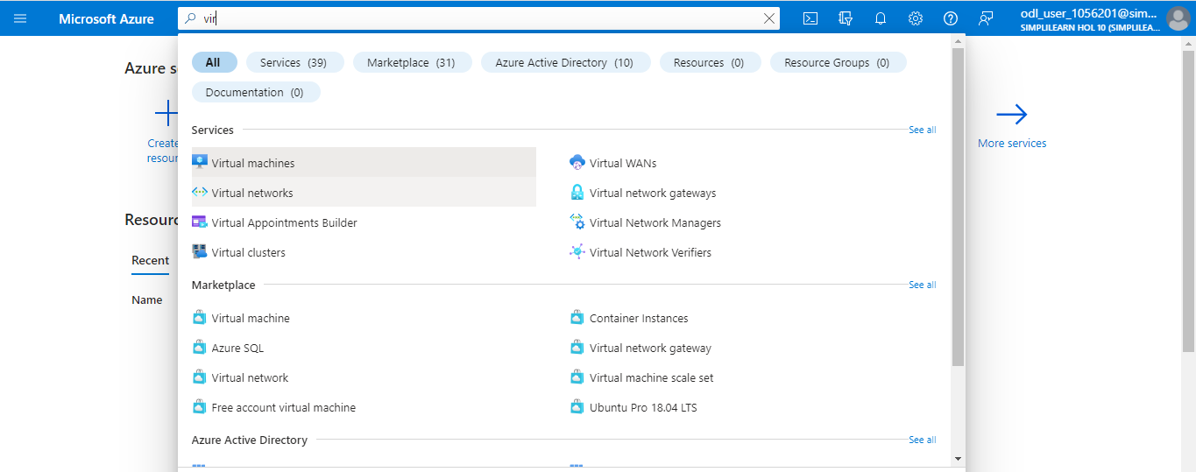

  - Click on + Create

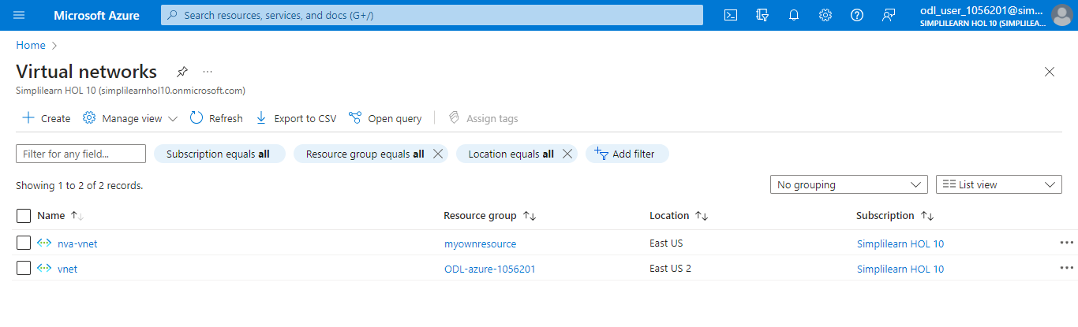

1.3 Enter the following information in the Basics tab:
- Subscription: Select Azure subscription
- Resource group: Enter lb-rg (Click on Create new)
- Virtual network name: lbVnet
- Region: West Europe

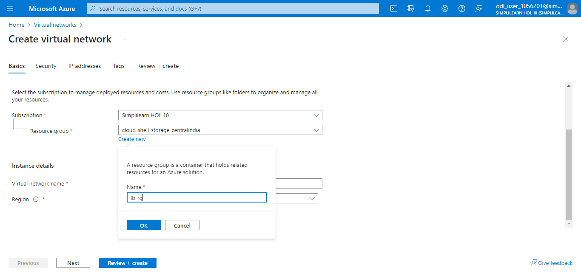

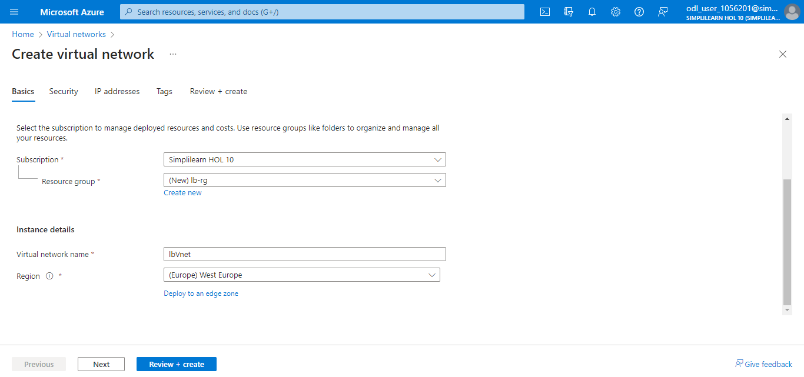

- In the IP addresses tab, select Add IPv4 address space and enter 10.0.0.0/16

- Click on + Add a subnet

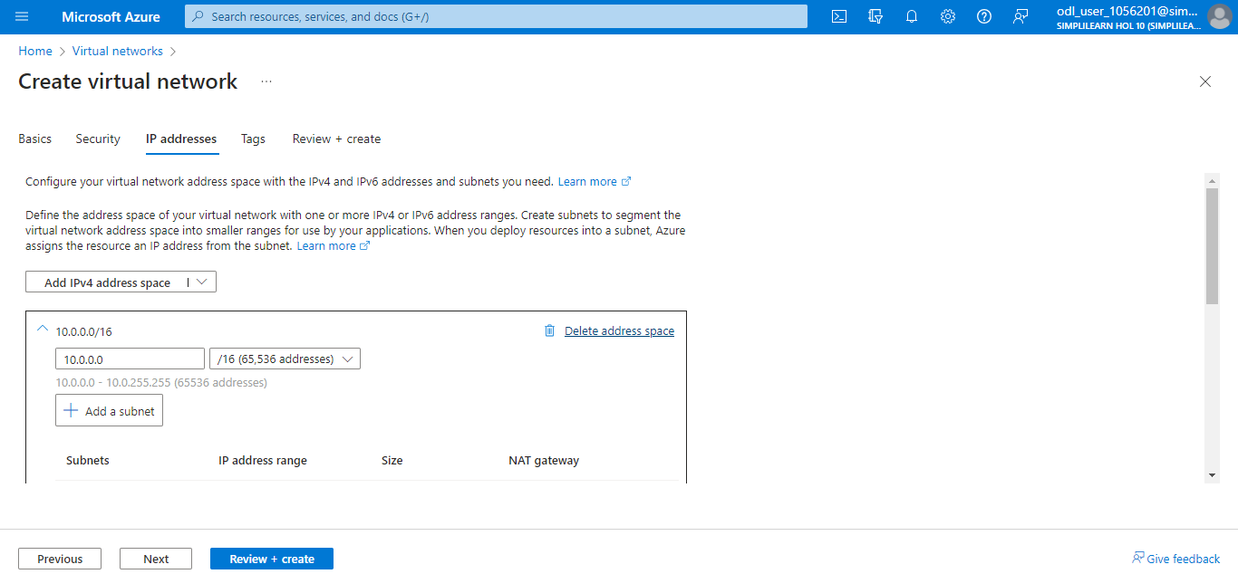

- In the Add a subnet panel, enter the following information:
- Name: lbSubnet
- IP address space: 10.0.0.0/16
Now, click on Add.

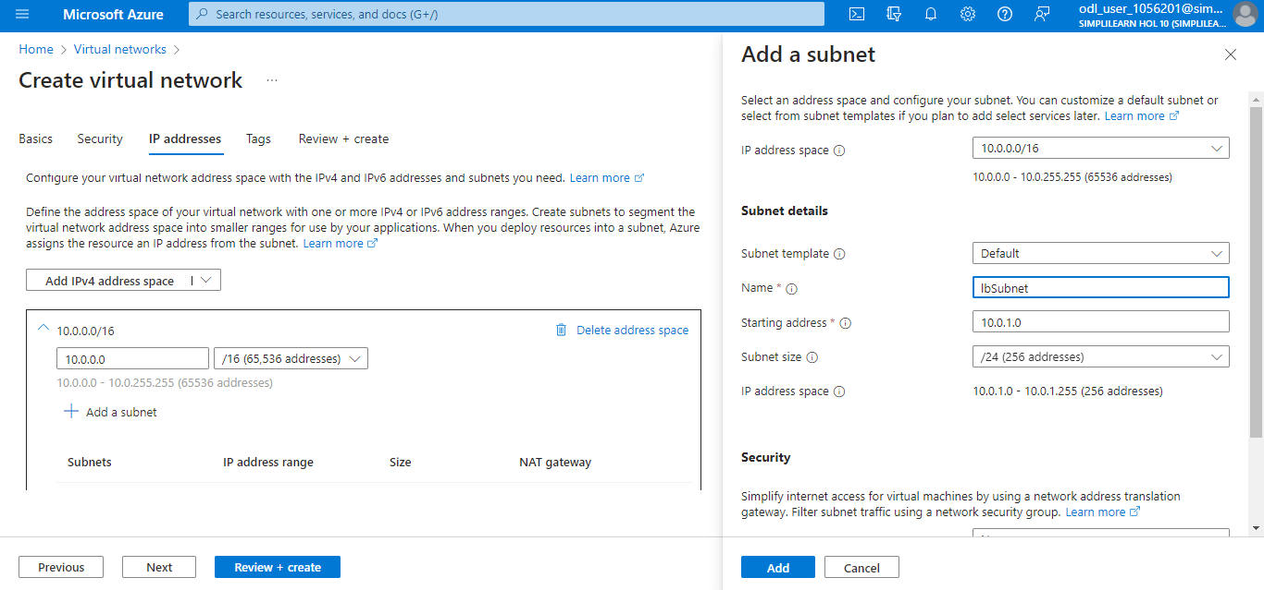

- Select the Security tab:
- Enable Azure Bastion: Tick the checkbox
- Azure Bastion host name: Enter lbbastionHost
- Azure Bastion public IP address: Select Create a public IP address and click OK

  - Click on Review + create

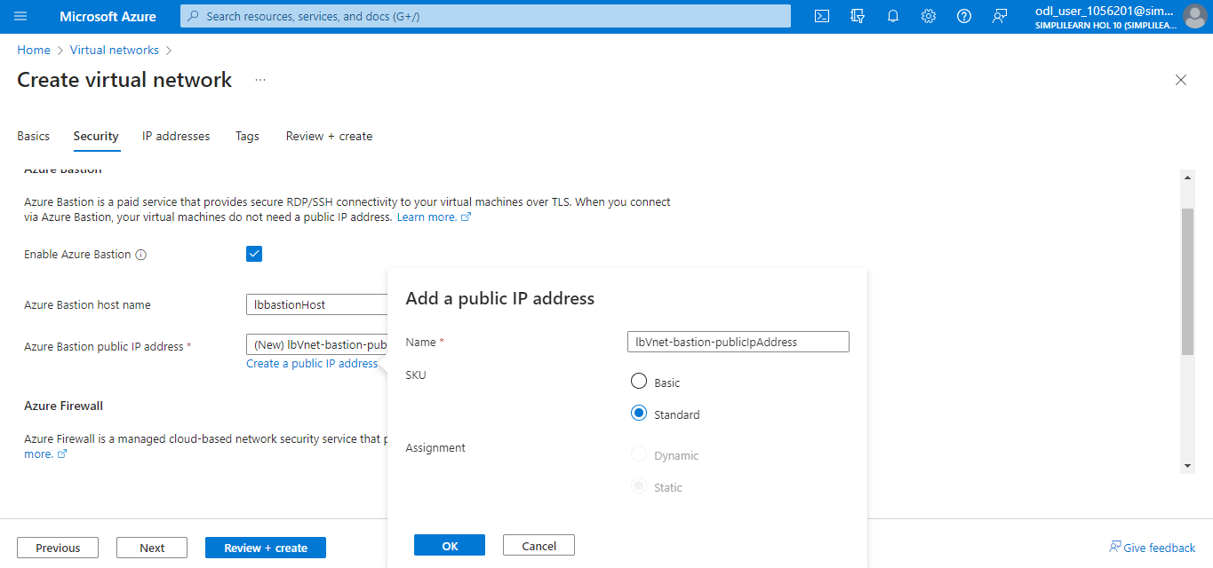

1.9 Click on Create

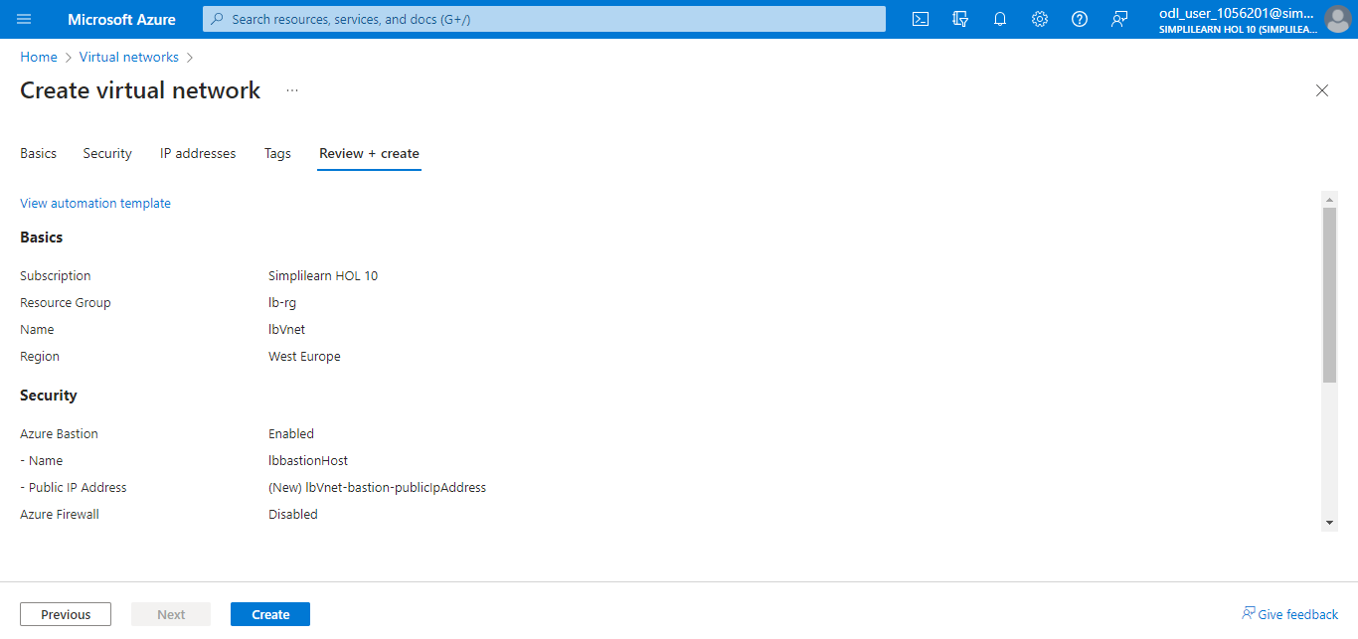

The following screenshot will appear:

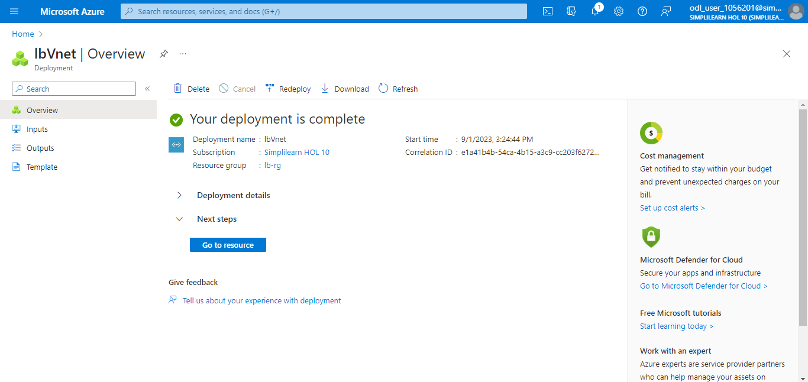

Step 2: Create a NAT gateway

  - Locate the NAT gateways in the Azure portal

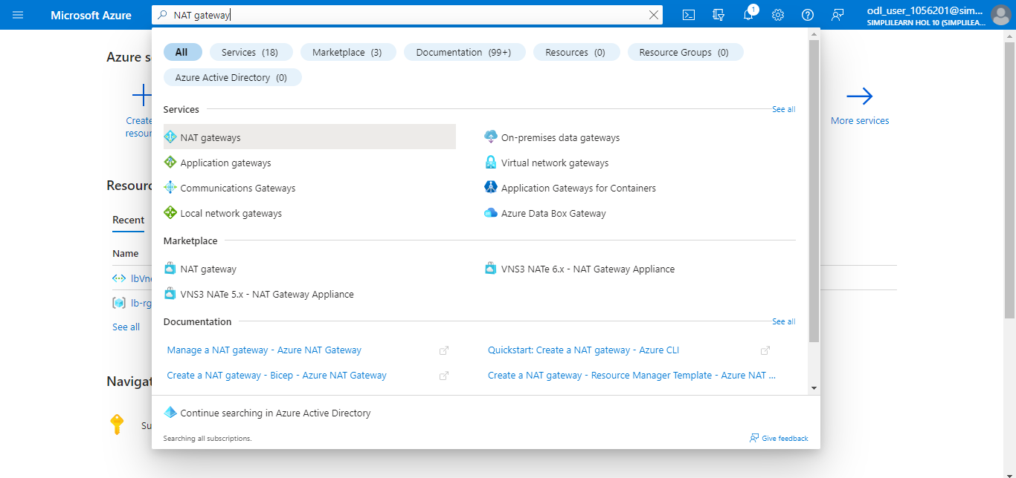

  - Click on + Create

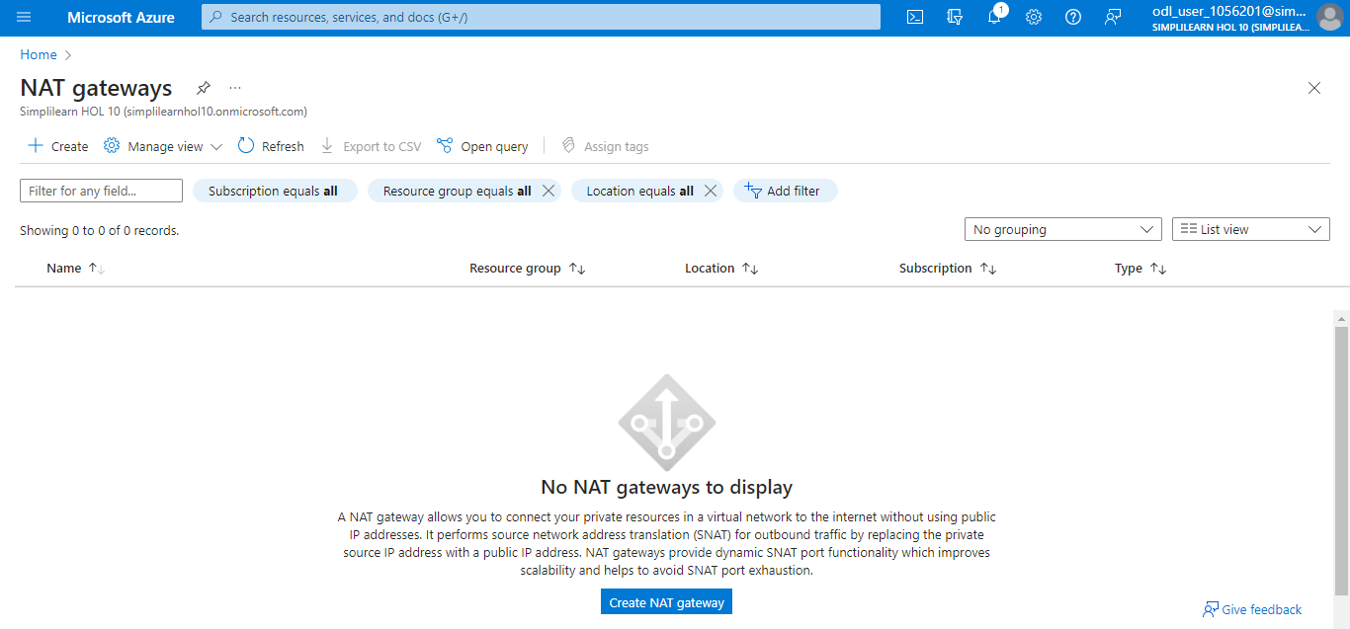

  - Provide the following information:
- Subscription: Select subscription
- Resource group: Select lb-rg1
- NAT gateway name: Enter lbNat
- Region: West Europe
- Availability zone: Select No Zone
- TCP idle timeout (minutes): Enter 15

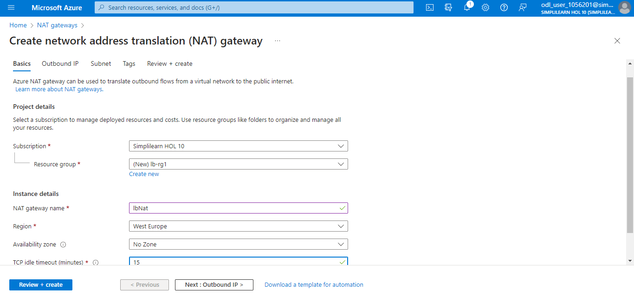

  - In the Outbound IP tab, select Create a new public IP address

  - Enter a Name in Add a public IP address and click OK

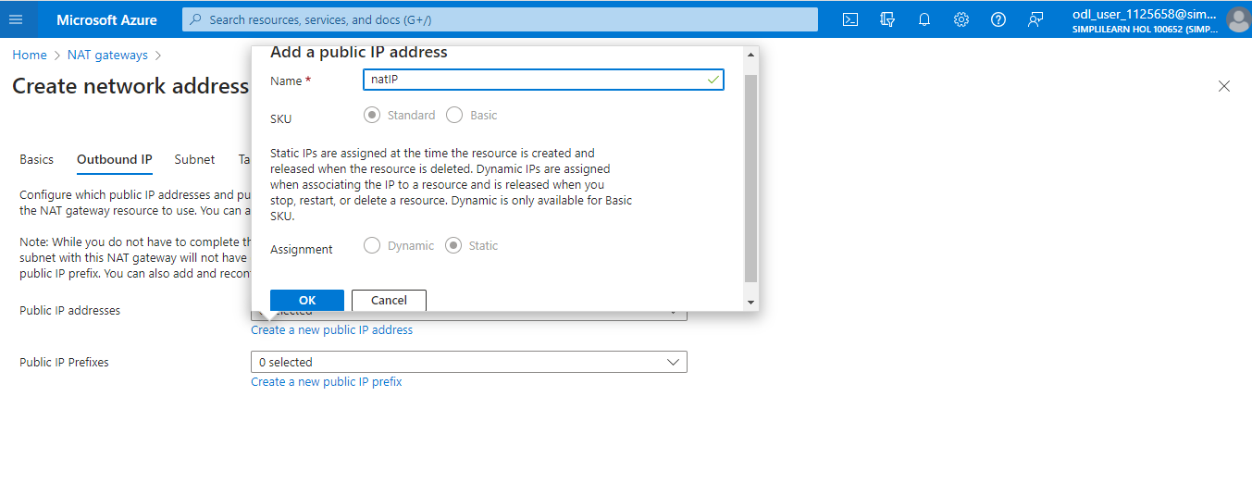

  - In the Subnet tab, perform the following:
- Select lbVNet in the Virtual network
- Select default in the subnet name
- Click on Review + create

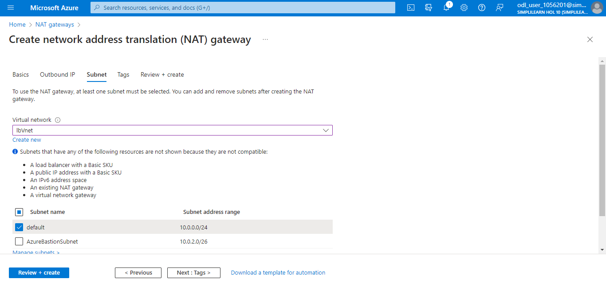

  - Click on Create

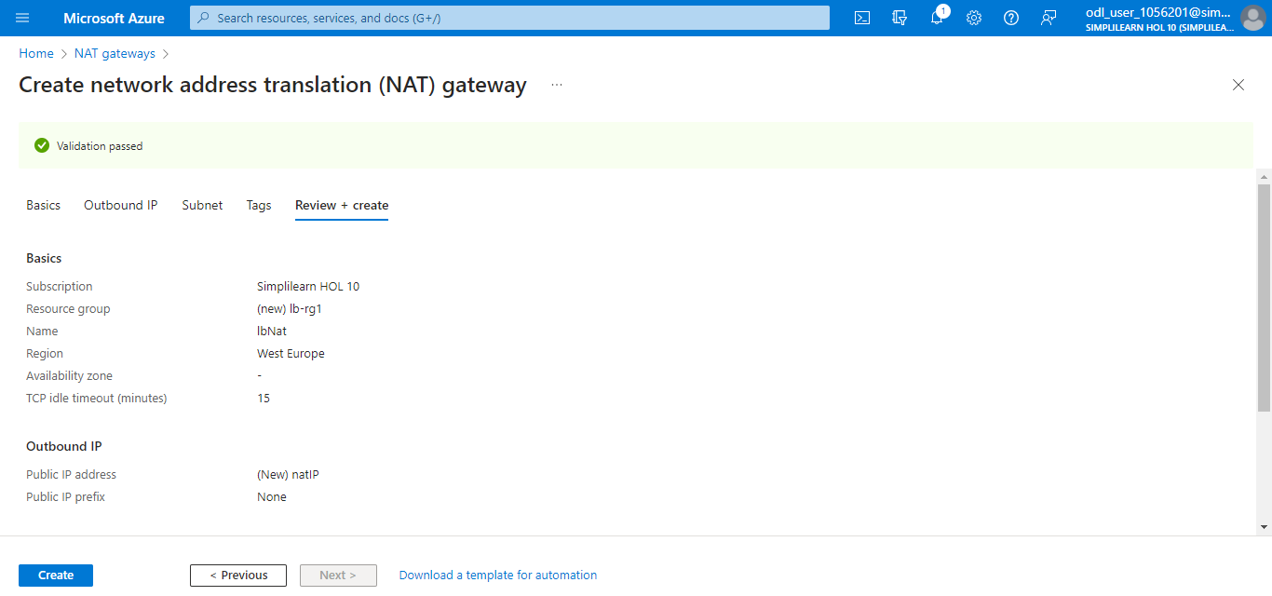

The following screenshot will appear:

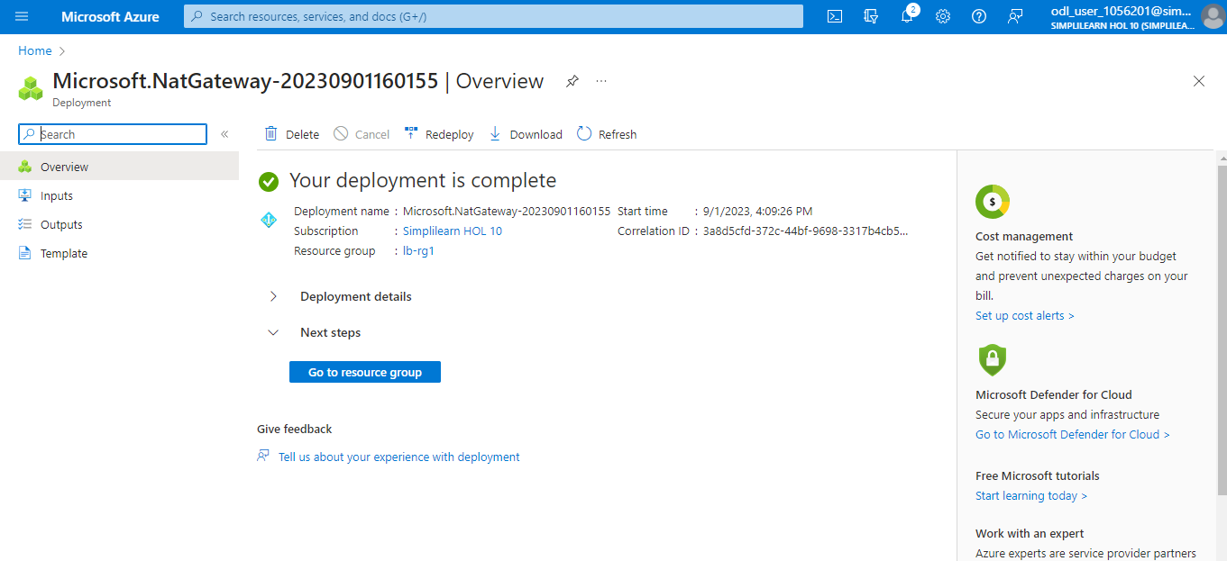

Step 3: Create a load balancer

3.1 Search for and select Load balancers

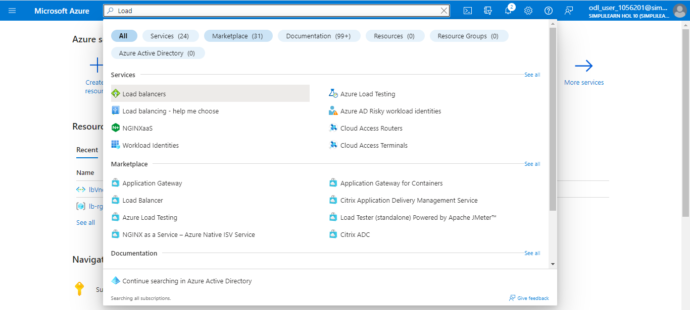

  - Select + Create

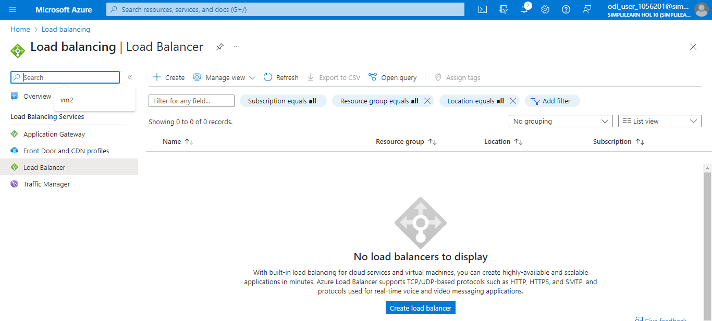

  - In the Basics tab, enter the following information:
- Subscription: Select your subscription
- Resource group: Enter lb-rg2 (click on Create new)
- Name: Enter publicLB
- Region: Select (Europe) West Europe
- Type: Select PublicLB
- SKU: Leave the default Standard
- Type: Internal
- Tier: Regional

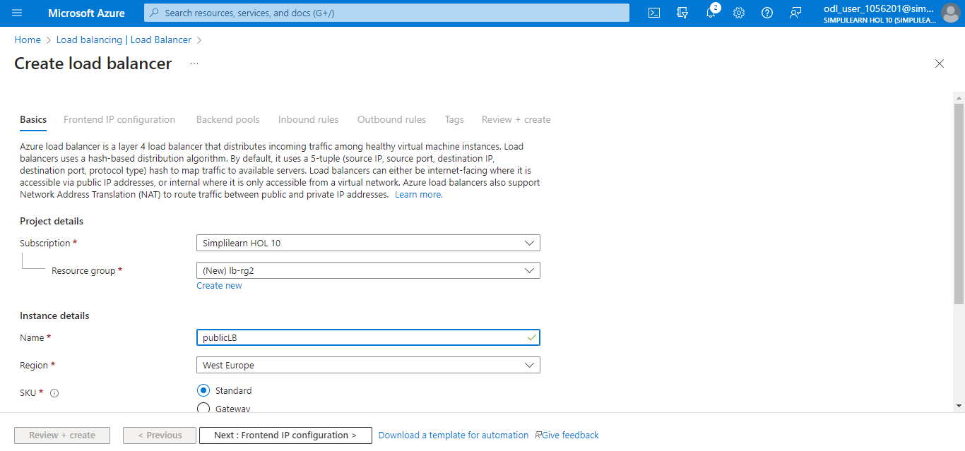

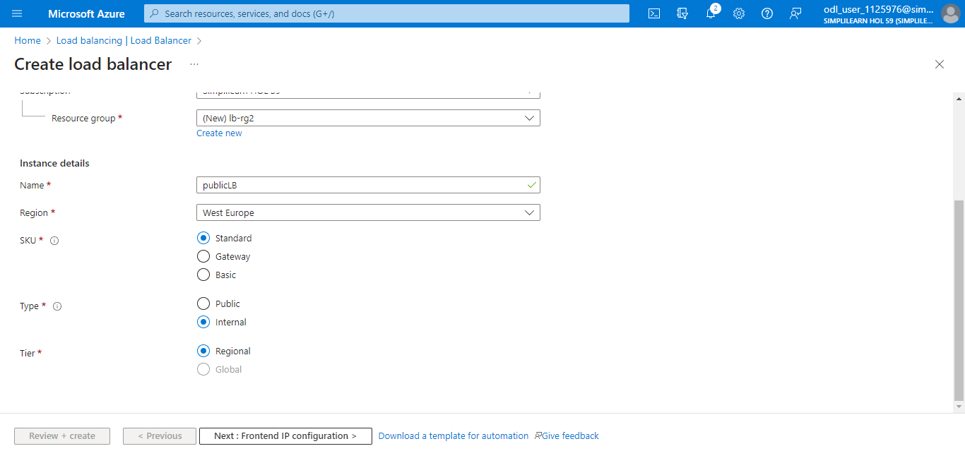

  - In the Frontend IP configuration tab, select + Add a frontend IP configuration and enter the following details:
- Name: LoadBalancerFrontend
- IP version: IPv4
- IP type: IP address
- Public IP address: Select Create new, choose Zone-redundant in Availability zone, and click OK

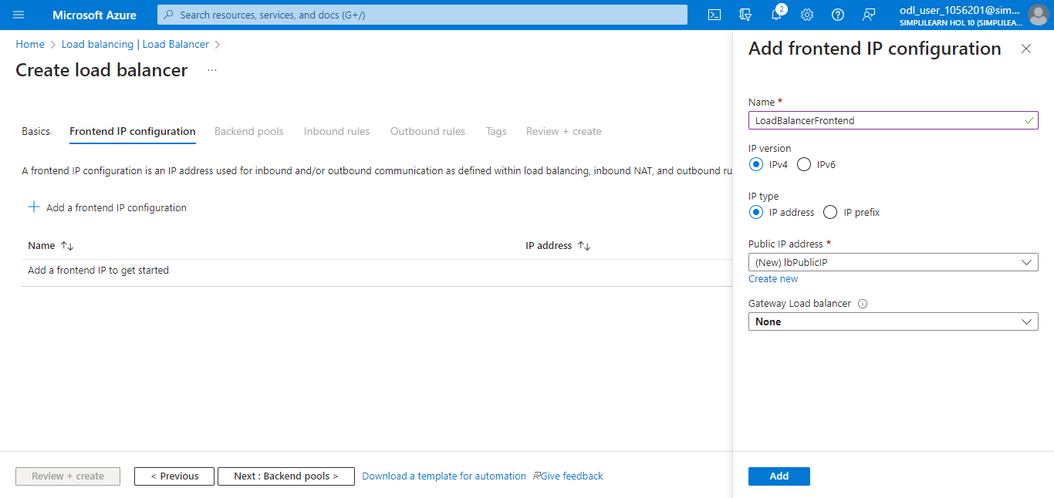

  - Click on Add

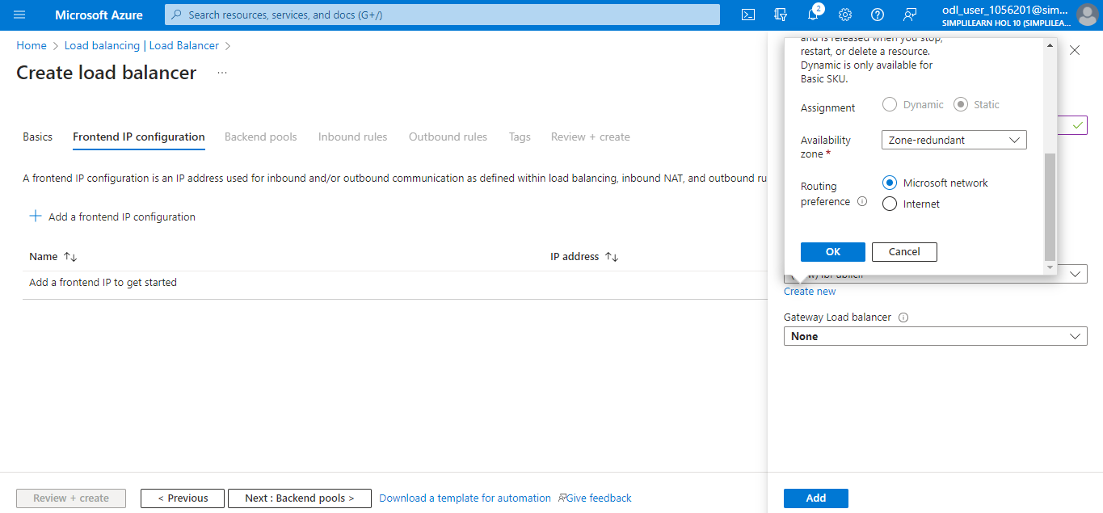

  - In the Backend pools tab, select + Add a backend pool

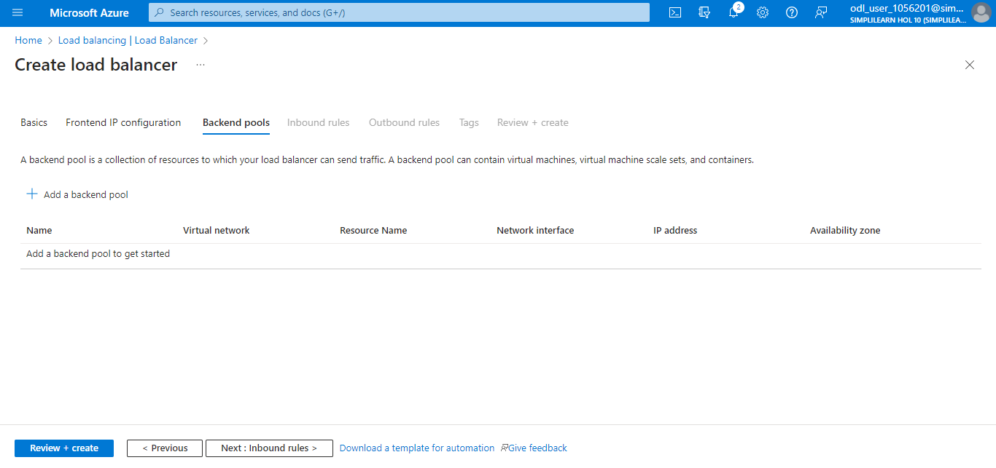

  - Enter the following details:
- Name: IbBackend
- Virtual network: lbVNet (Ib-rg)
- Backend Pool Configuration: NIC
- Click on the Save button.

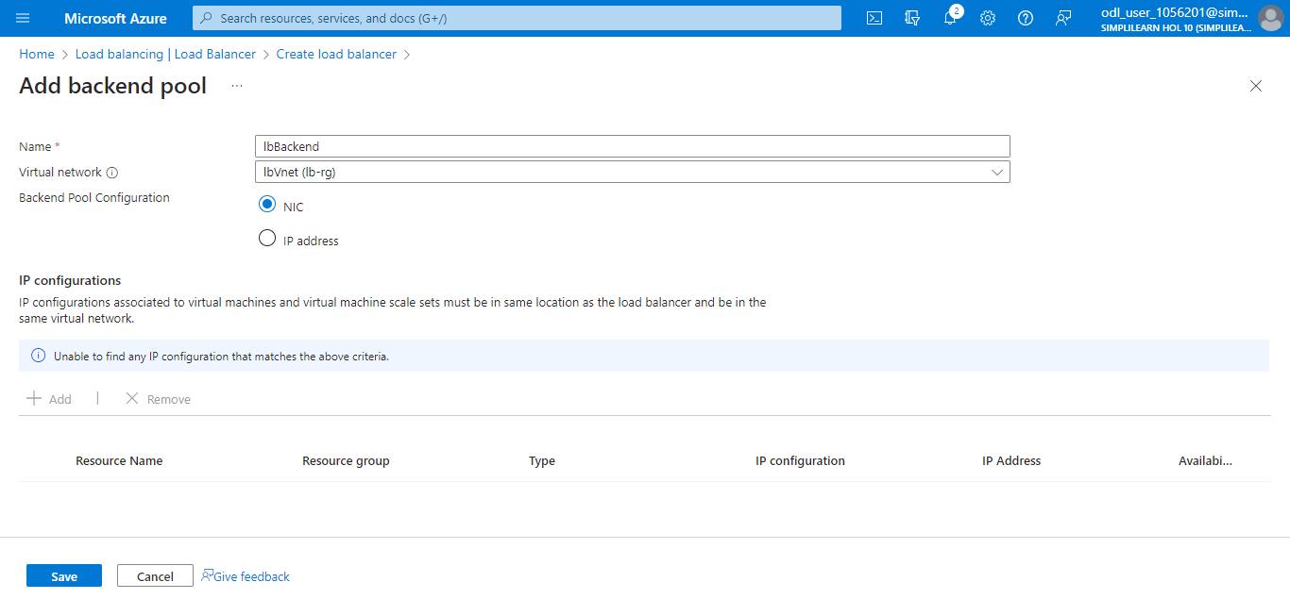

  - In the Inbound rules tab, select + Add a load balancing rule

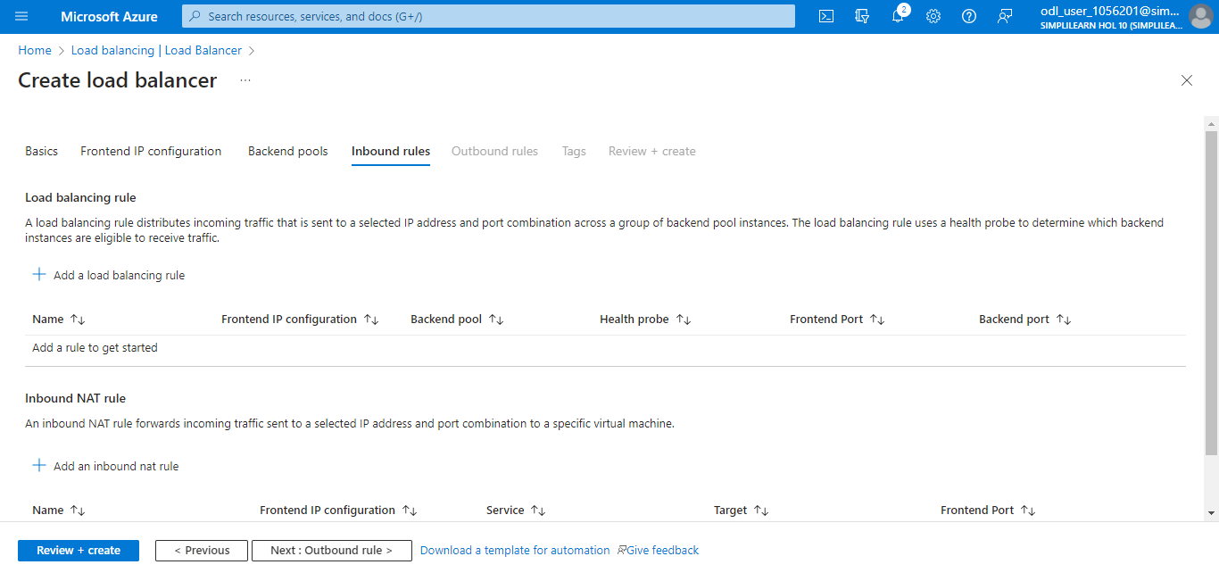

  - Enter the following details:
- Name: Enter myHTTPRule
- IP Version: Select IPv4 or IPv6 depending on the requirements
- Frontend IP address: Select LoadBalancerFrontend
- Backend pool: Select lbBackend
- Protocol: Select TCP
- Port: Enter 80
- Backend port: Enter 80

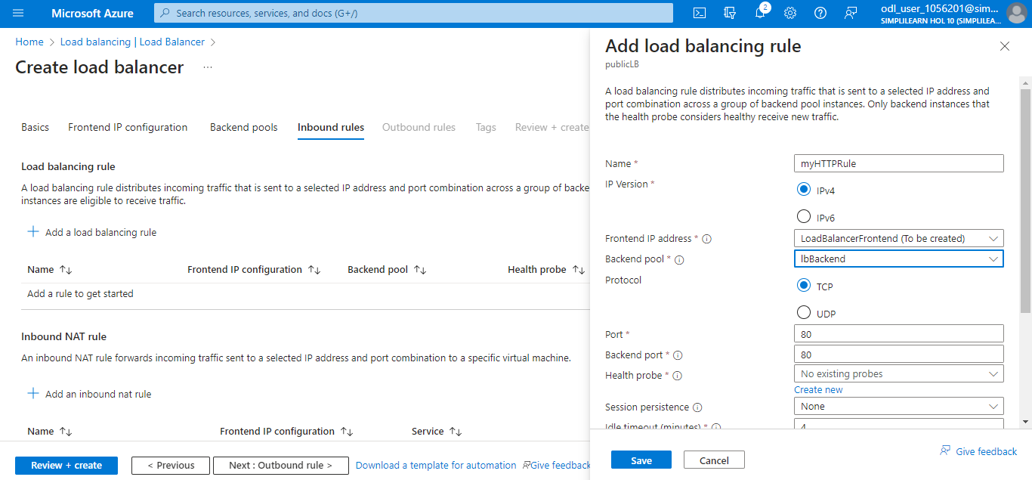

3.10 For Health probe: Choose Create new. Set the Name as lbHealthProbe and select TCP
as the Protocol. Keep the remaining fields at their default settings.

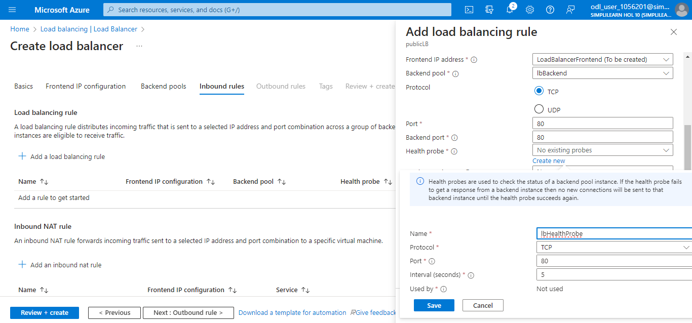

  - Add the rest of the information as shown below:
Session persistence: Select None
Idle timeout (minutes): Enter 15
Enable TCP reset: Tick the checkbox
Enable Floating IP: Untick the checkbox

  - Click on Save

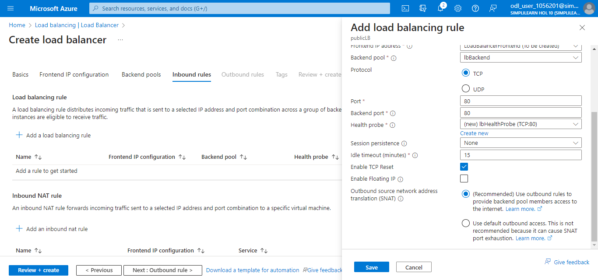

The following screenshot will appear:

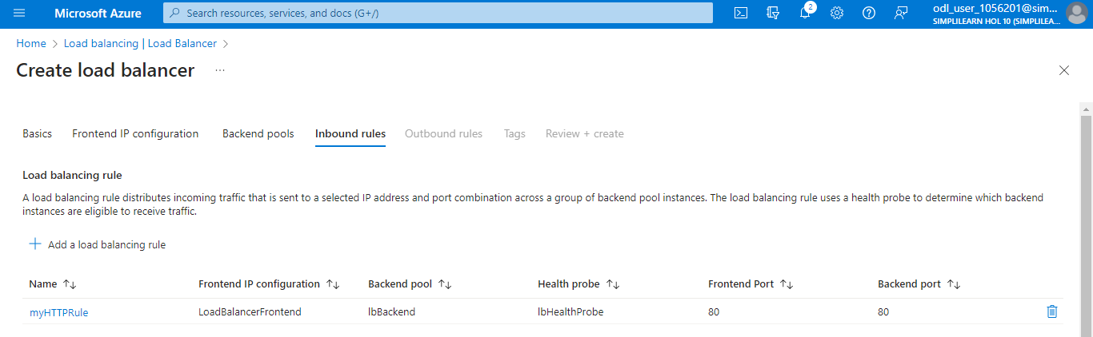

Step 4: Create virtual machines

4.1 Search for and access Virtual machines

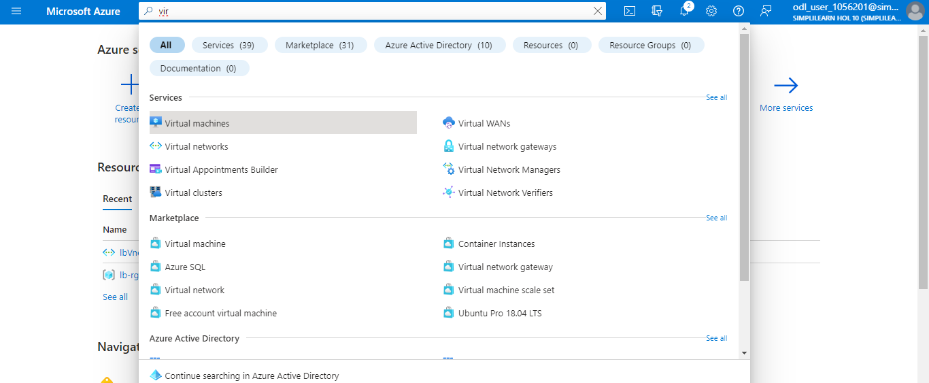

4.2 Click on + Create to create three VMs (vm1, vm2, and vm3) in three different zones
(Zone 1, Zone 2, and Zone 3)

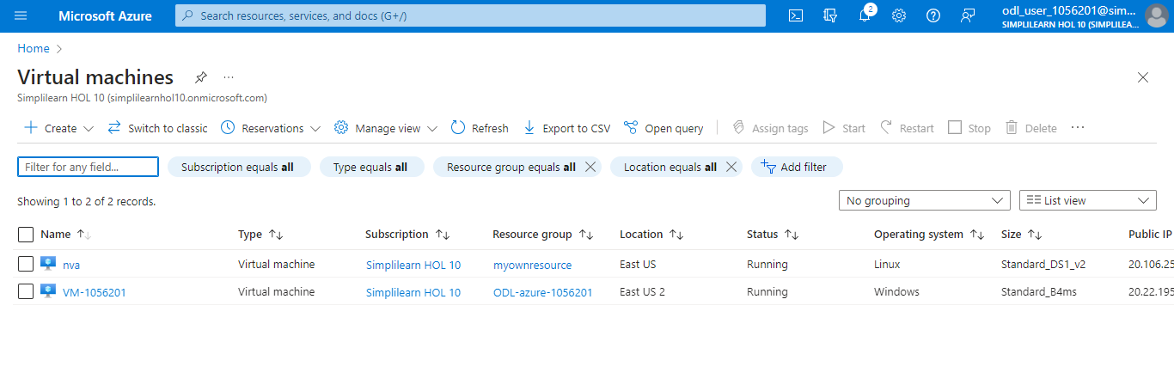

  - Enter the following details in the Basics tab:
  - Subscription: Select your subscription
  - Resource group: Select lb-rg4 (Click on Create new)
  - Virtual machine name: Enter vm1
  - Region: Select (Europe) West Europe

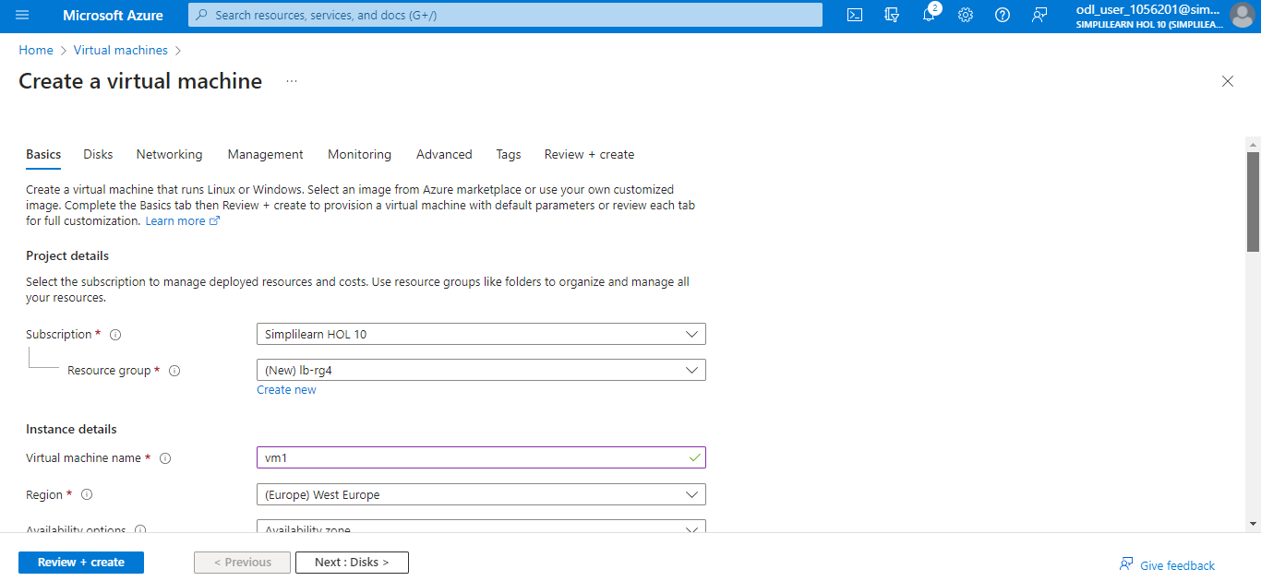

Continuing in the Basics tab, enter the following details:
- Availability options: Select Availability zone
- Availability zone: Select Zones 1
- Image: Select Windows Server 2019 Datacenter – Gen2
- Administrator account: Enter username and password

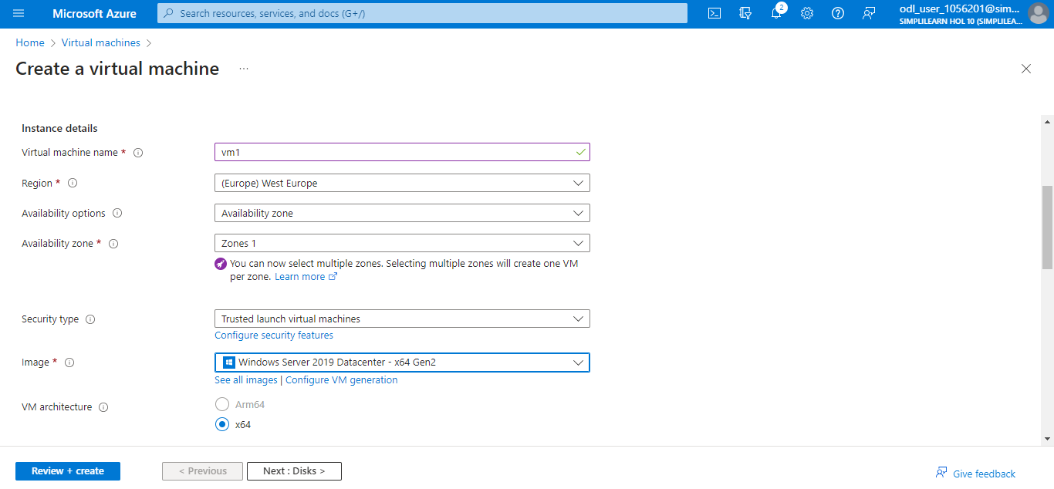

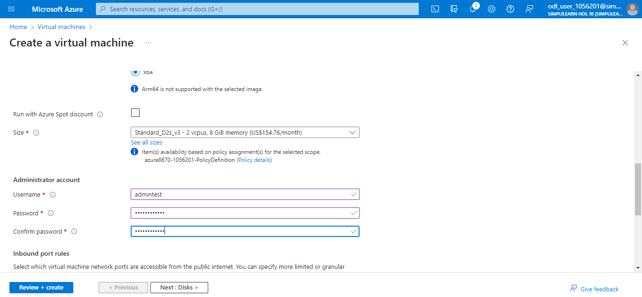

  - In the Networking tab, enter the following details:
Virtual network: lbVnet
Subnet: lbSubnet
Public IP: Select None
NIC network security group: Select Advanced

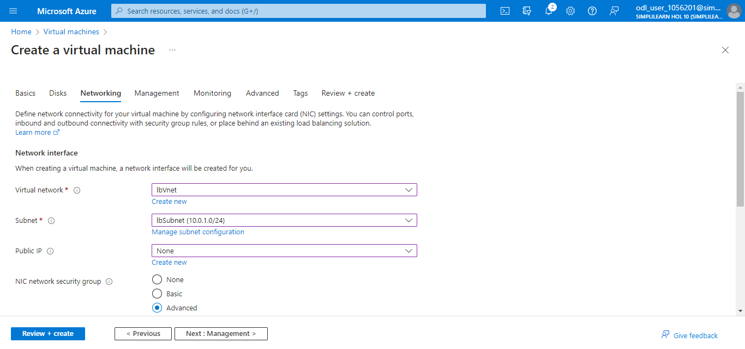

  - In Configure network security group, select Create new and enter Name as vm1-nsg

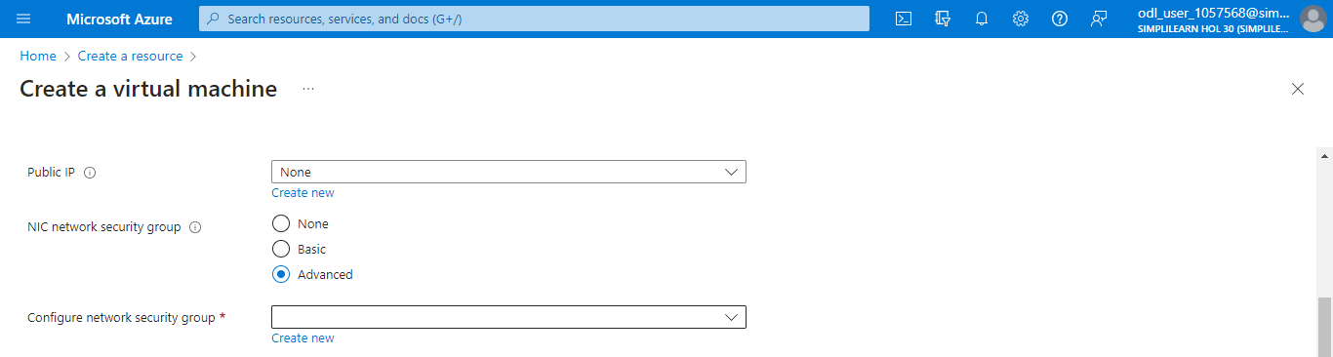

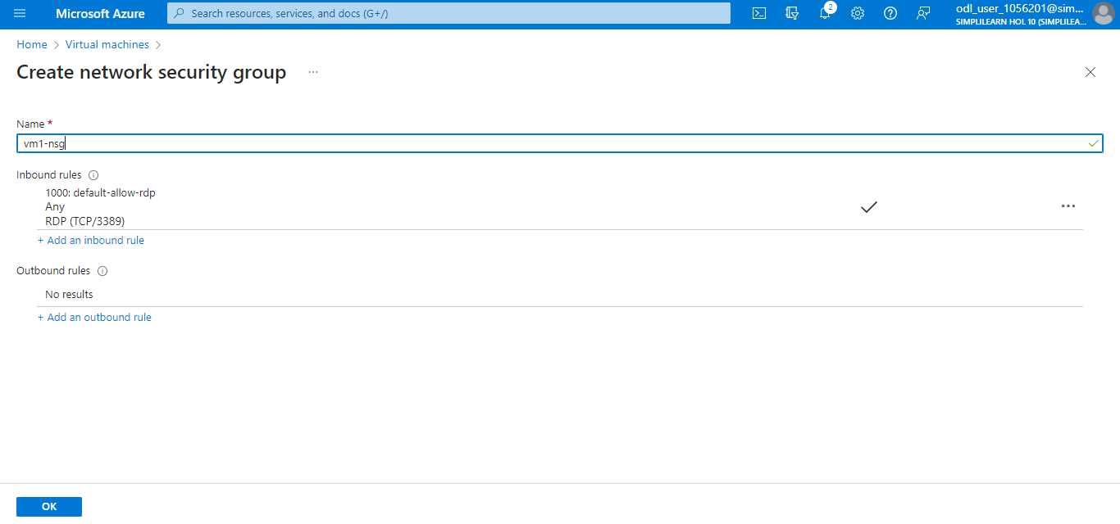

  - Under Inbound rules, select + Add an inbound rule and enter the following details:
- Service: Select HTTP
- Priority: Enter 100

4.7 Click on Add and select OK

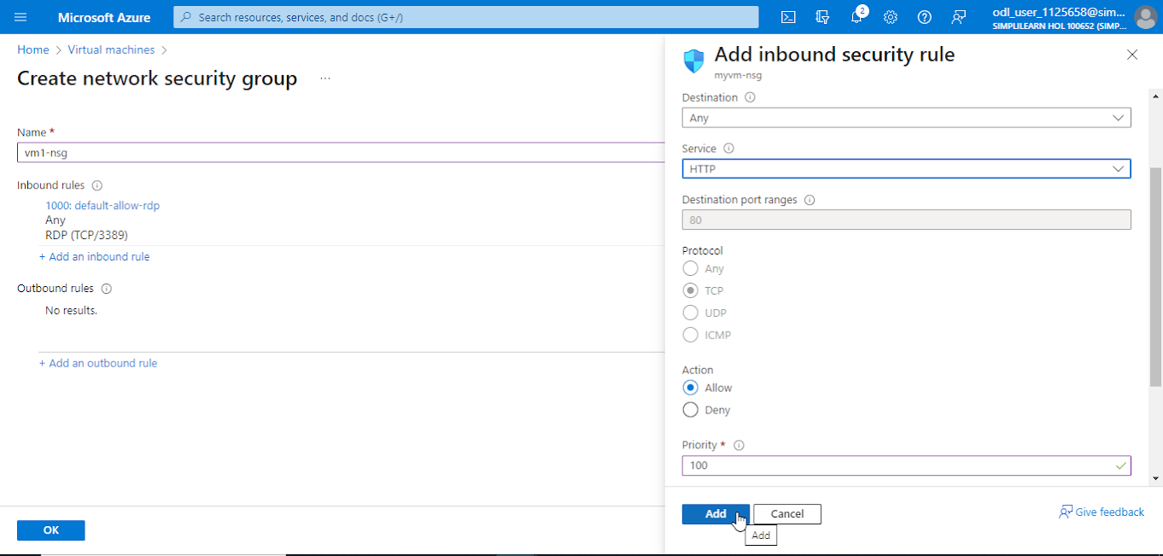

  - In the Load-balancing options, select Azure load balancer
Now, under Create a load balancer, give the following details:
- Load balancer name: myloadbalancer
- Type: Public
- Protocol: TCP
- And then, click on Create

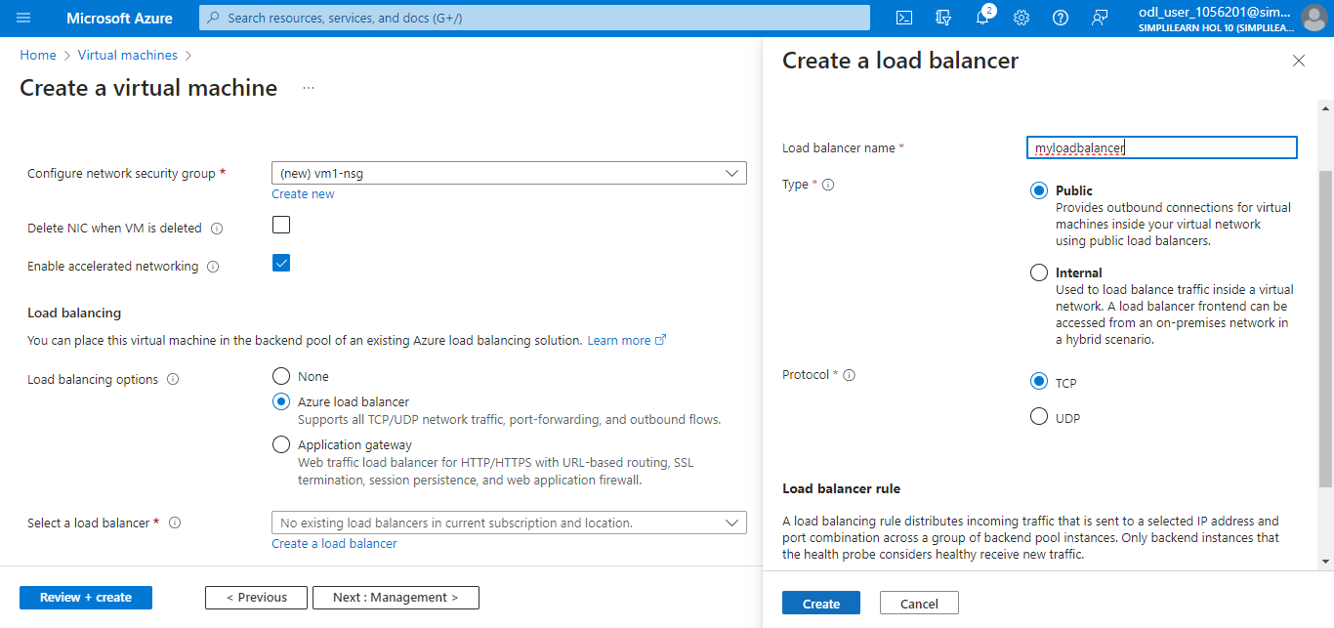

  - Under Select a backend pool, select myloadbalancer-backendpool01

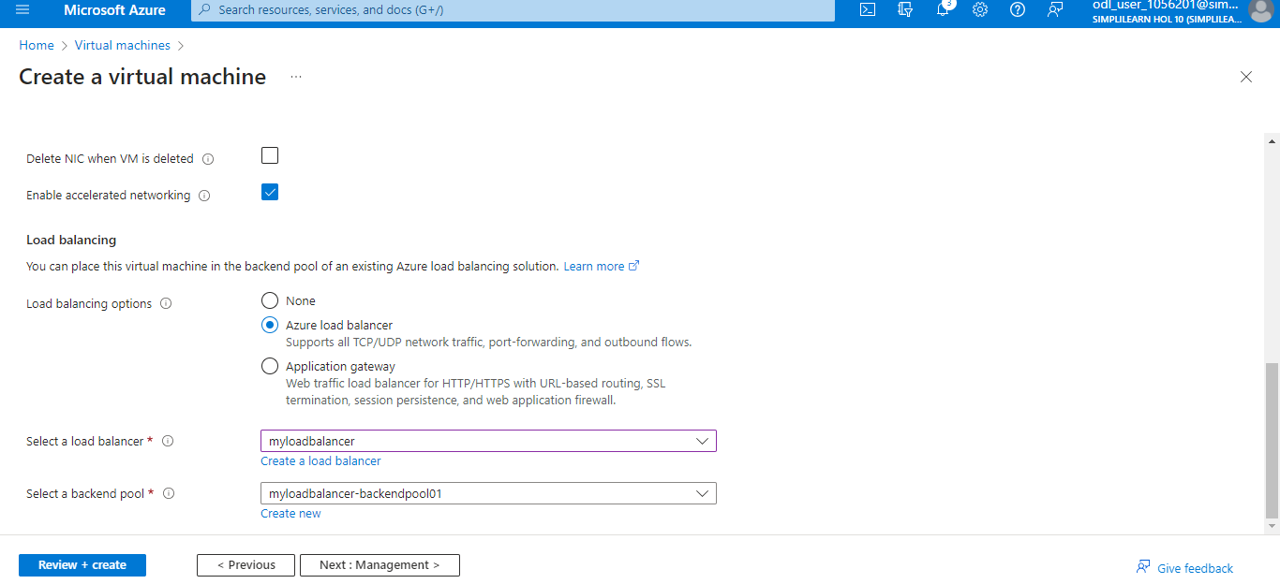

4.10 Select Review + create

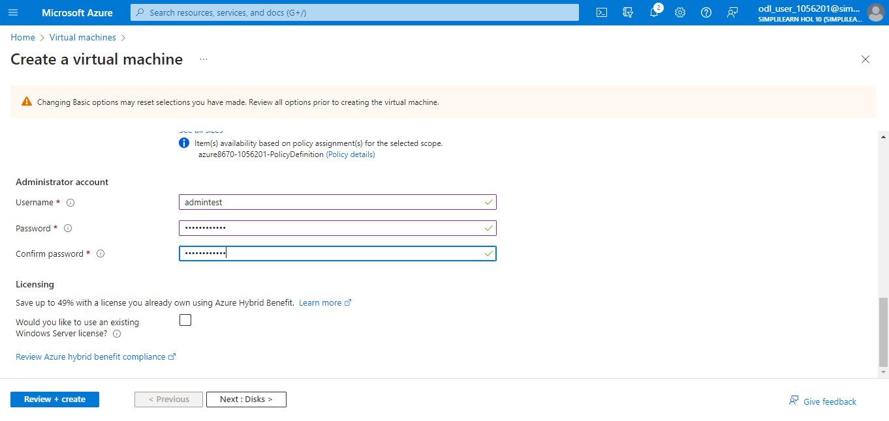

4.11 Click on Create

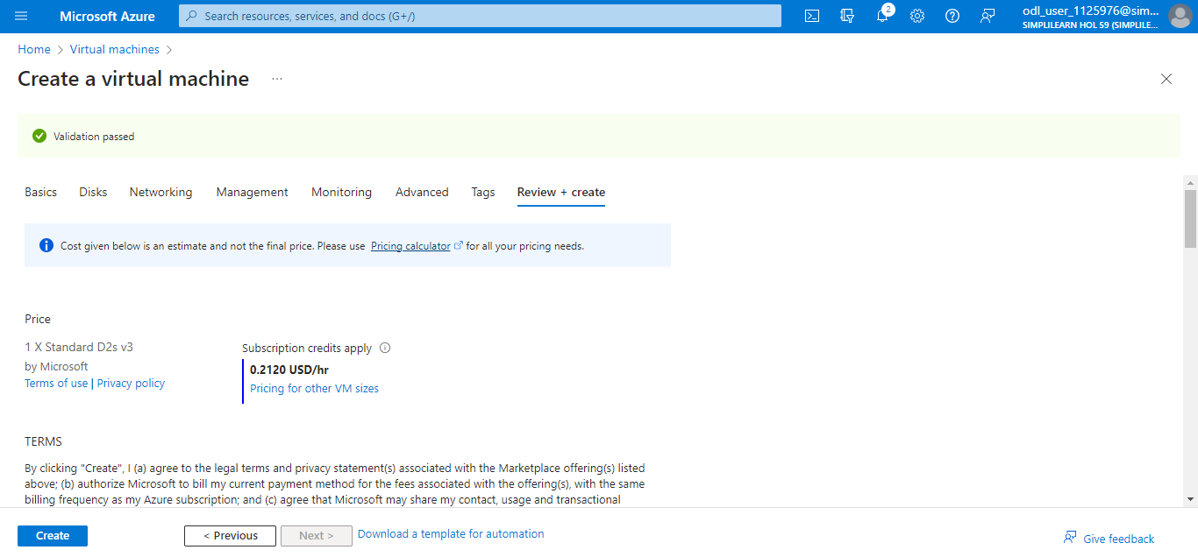

The output will appear as follows:

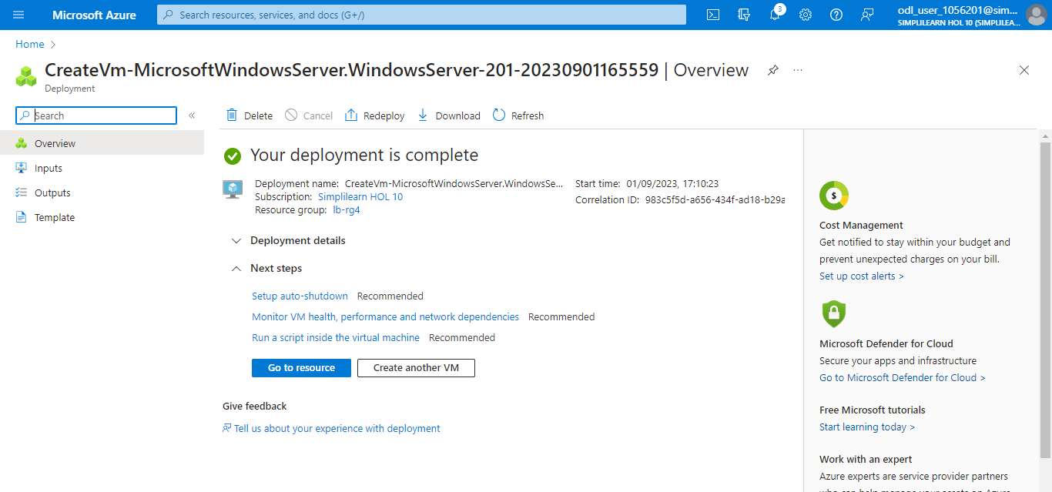

Note:
Follow the same steps for vm2 with availability zone 2 and vm3 with availability
zone 3. Now, select the vm1-nsg created for the first VM.

Step 5: Install IIS

  - Select vm1 created in step 4

  - On the overview page, navigate to Connect

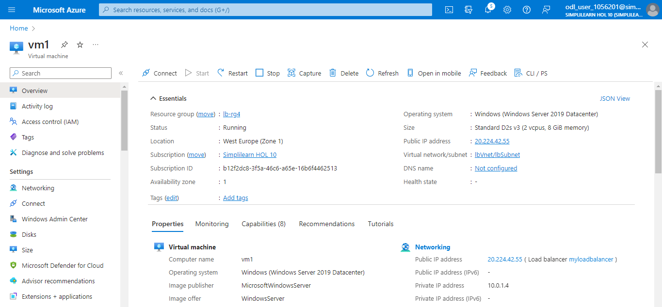

  - Click on Connect and select Go to Bastion

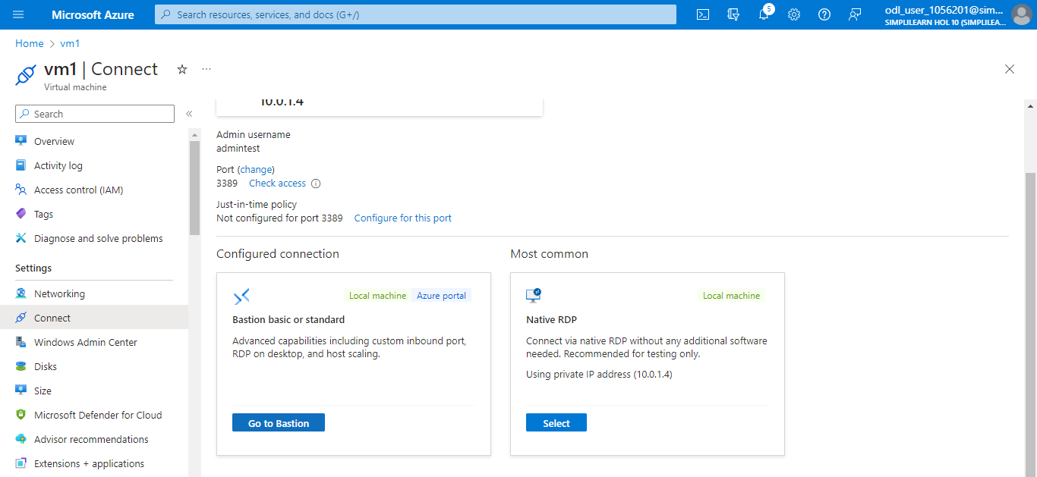

  - Enter the Username and VM Password entered during the VM creation

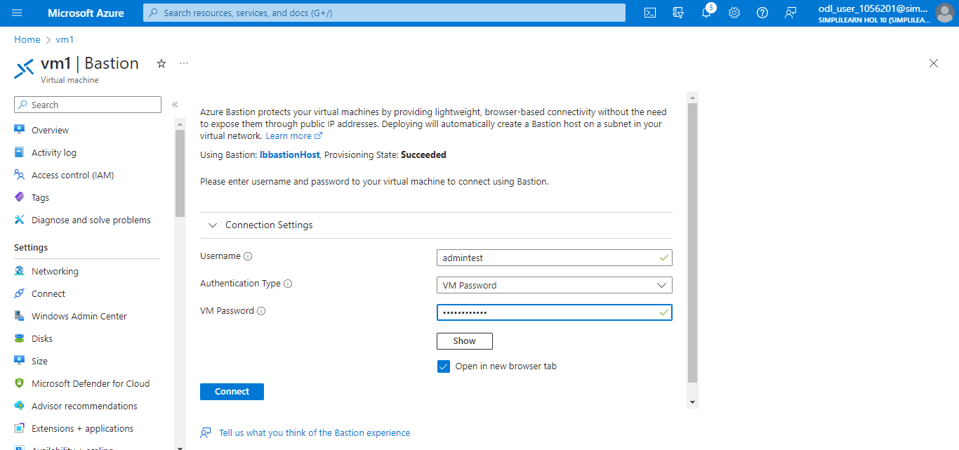

  - On the server desktop, navigate to Windows Administrative Tools and select Windows PowerShell

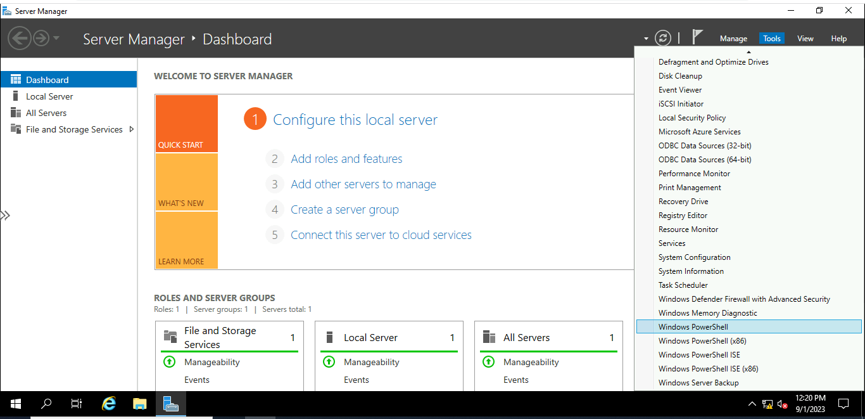

  - In the PowerShell window, run the following commands:

# Install IIS server role
Install-WindowsFeature -name Web-Server -IncludeManagementTools

# Remove default htm file
Remove-Item C:\inetpub\wwwroot\iisstart.htm

# Add a new htm file that displays server name
Add-Content -Path "C:\inetpub\wwwroot\iisstart.htm" -Value $("Hello World from " + $env:computername)

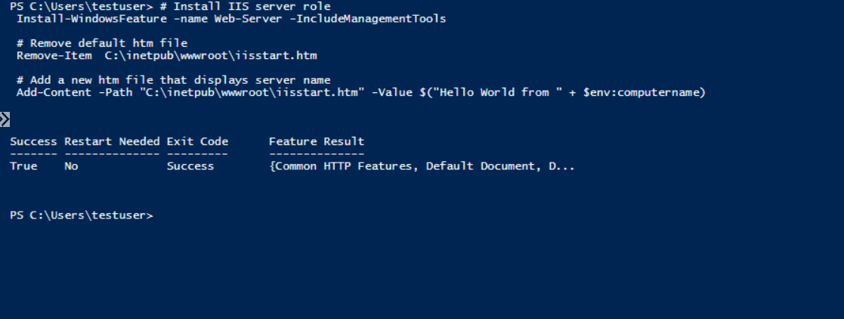

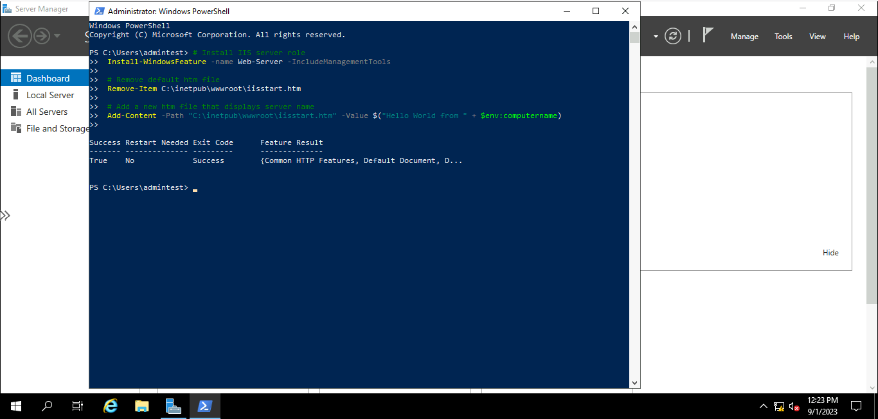

Repeat the above steps for vm2 and vm3 as well

Step 6: Test the load balancer

  - Find the public IP address for the load balancer on the Overview page

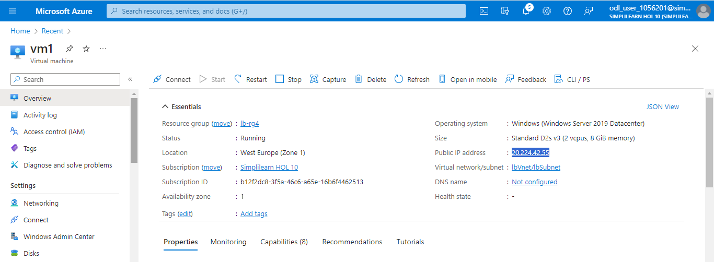

6.2 Copy and paste the public IP address into your browser's address bar to view the IIS web server's custom VM page

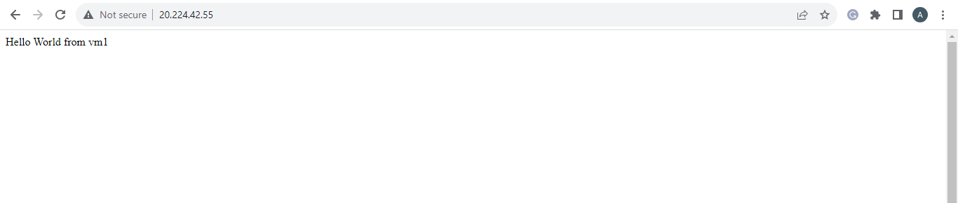

By following these steps, you have successfully created the public load
balancer to distribute the traffic to backend Virtual machines.

